Your starting point is the completed version of Exercise 7.2. If you already closed that file, please reopen it using the Power BI software. You should first complete the previous exercise before starting with this one. If you just wrapped up the last assignment, your view would probably look like the image below.

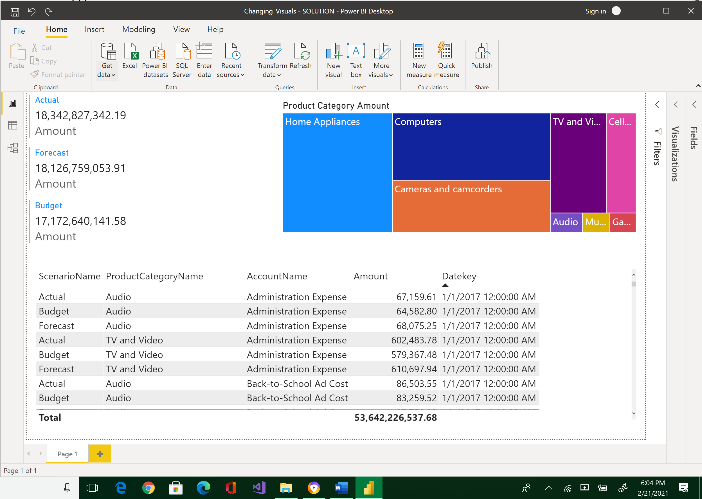

Let's keep working on this report and make it look even nicer. This time around, you are going to edit the bottom visual in the report. We want to see the data in a summarized way, so the table needs to become a matrix.

* Change the table to a matrix. To do this, highlight the table, and click Matrix from the Visualizations pane.

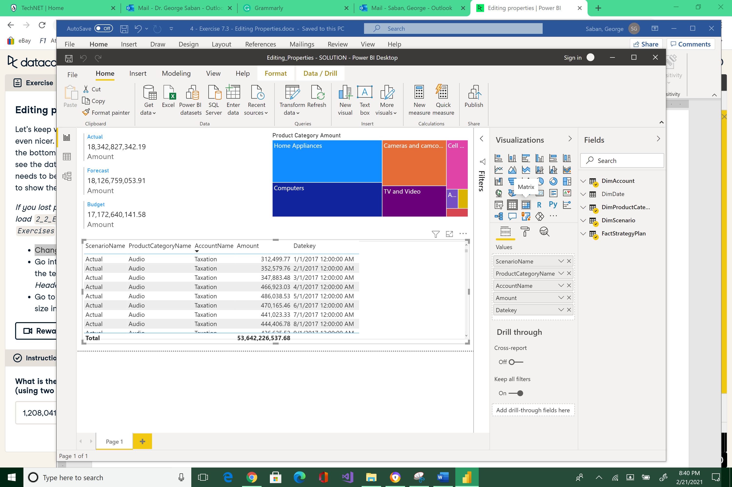



The grid is now a Matrix.

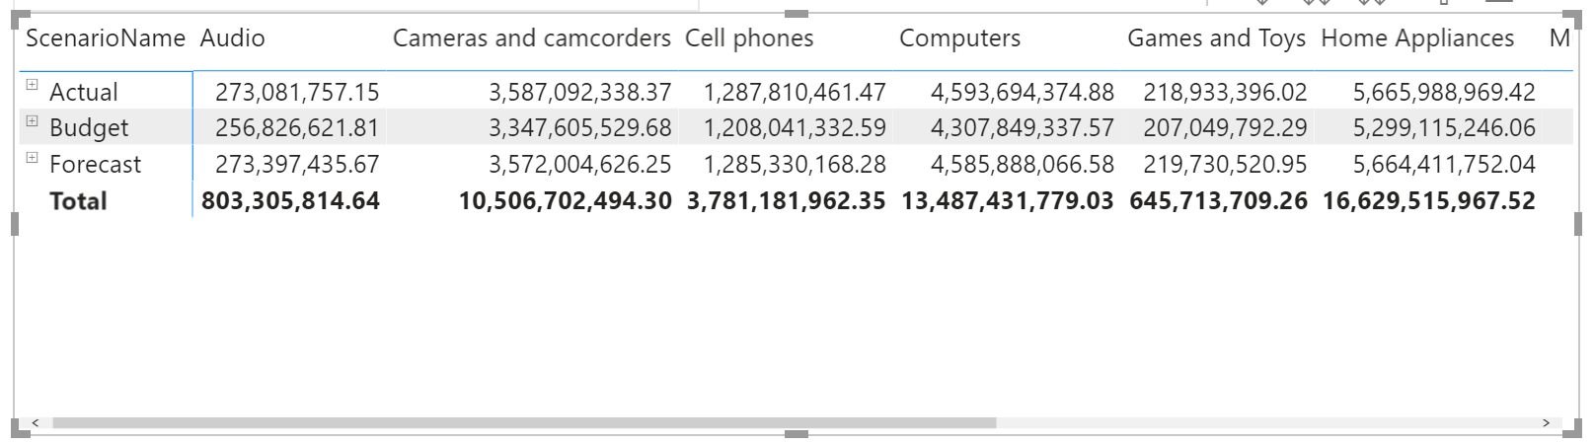

* Go into the formatting settings and change the text size of the *Row Headers* and *Column Headers* to 18. While the matrix is still enabled, click the Format icon.

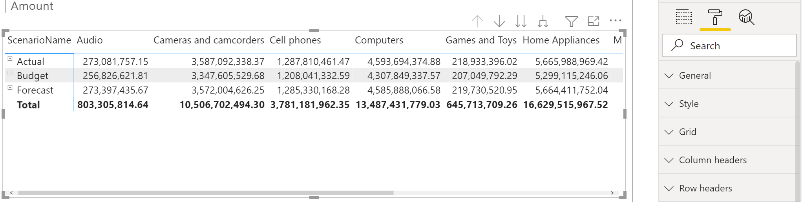



* Select arrow-down of Column or Row headers section.

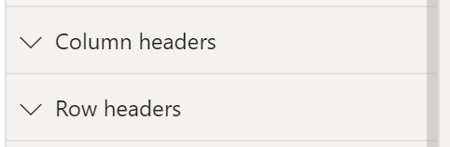



* Change Text size to 18.

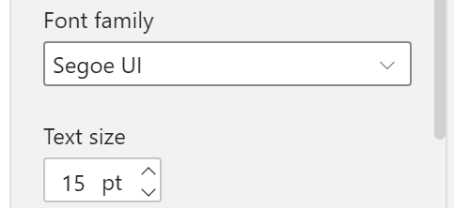



* Make this modification for both Column and Row properties. Your matrix’s column and row headers should now be larger.

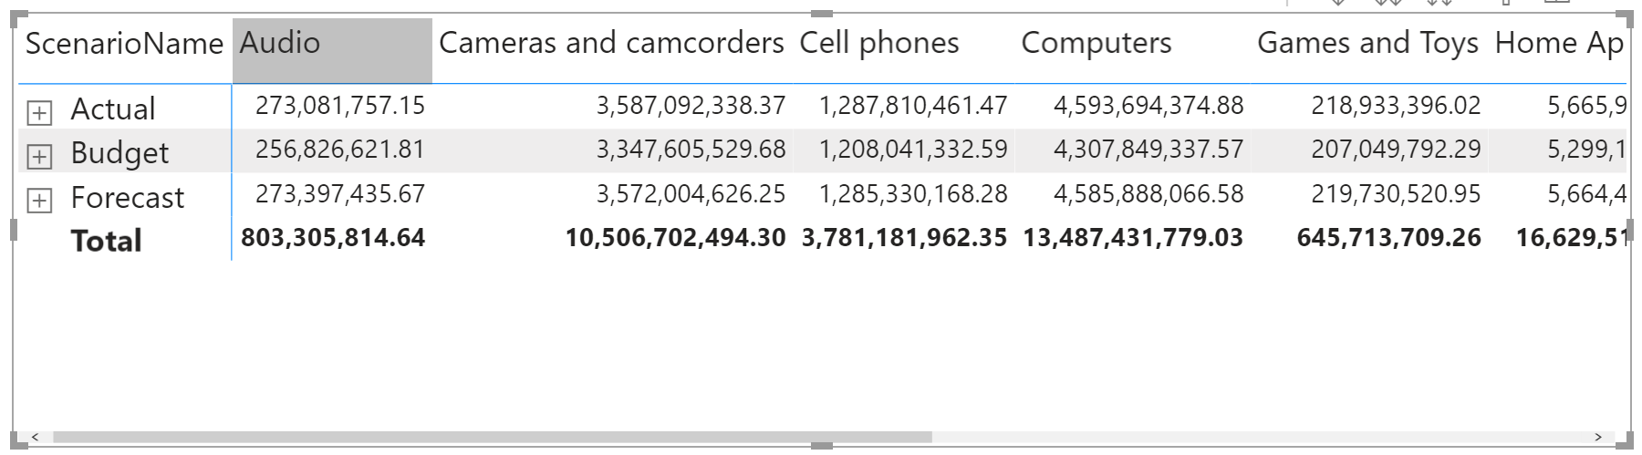

* Go to the *Values* section to change the font size in the rest of the columns to 18 as well.

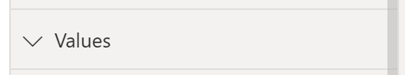



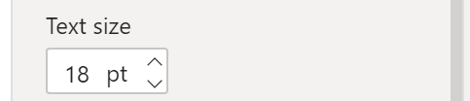



* **What is the budgeted amount for cell phones (using two decimal points)?**

|  |
| --- |
| 1,208,041,332.59 |

Please reposition your Report so that it would look like the image below. Take a snapshot using Window's Snipping Tool. Make sure the encircled items are included. Place your image at the end of this document (after the example below) and submit this completed artifact to Canvas in Word format.  Thank you for your efforts!

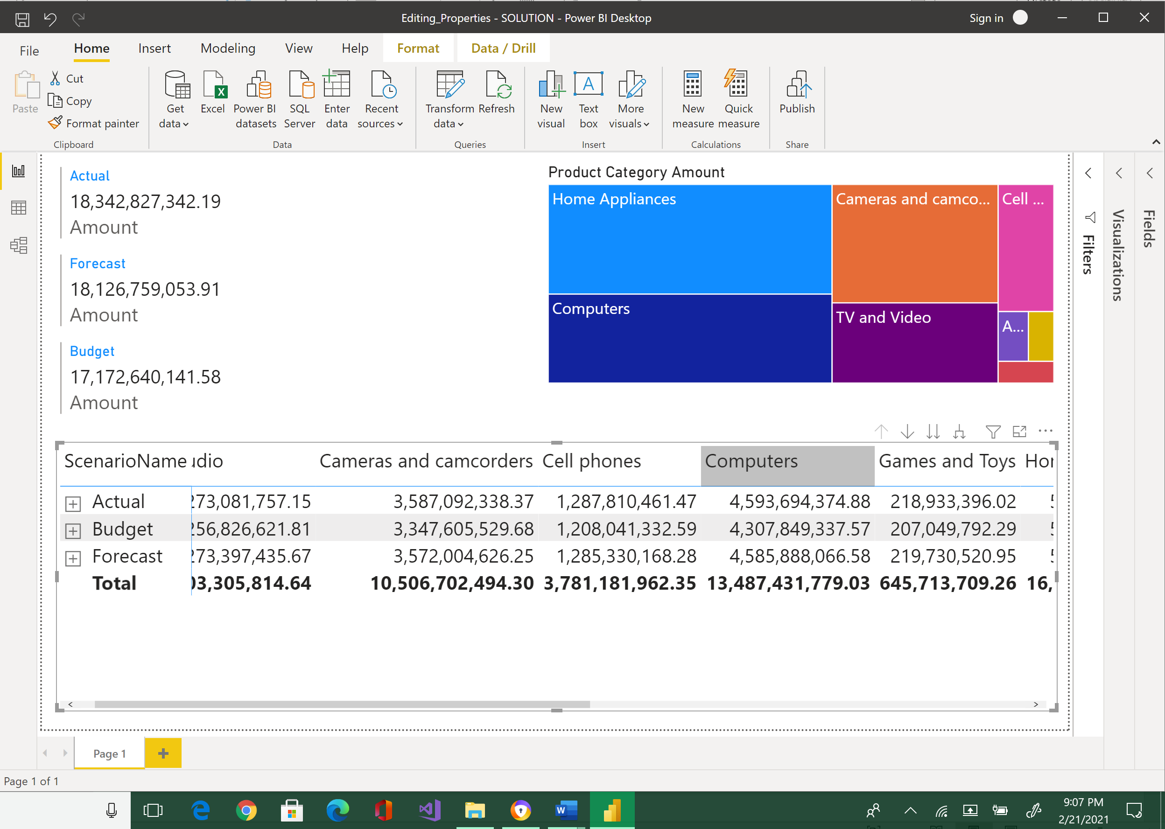



|  |
| --- |
| Please paste here your final image. |